Manuscript received: Journal of Agriculture and Plant Sciences, JAPS
Accepted: Vol --, No. -, pp. -- - -- (201-)
In print: ISSN 2545-4447
On line: ISSN 2545-4455
UDC: ----------------------
Filled up by Editorial office of JAPS Original scientific paper

PAPER TITLE (MICROPROPAGATION OF ORNAMENTAL SPECIES Brassica oleracea cv. Kyoto Red Given AND Ageratum sp.)

Name and surname^{1*}, Name and surname² of author/s,
¹Author/s address, (the address of more authors from different institutions to be noted with superscript)
²Author/s address, (the address of more authors from different institutions to be noted with superscript)
*Corresponding author: email address

Abstract
Text, text, text, text, text, text, text, text, text, text, text, text, text, text, text, text, text, text, text, text, text, text, text, text, text, text......
max 250 words

Key words: 3-7 words that are not included in the title

INTRODUCTION
Text, text, text, text, text, text, text, text, text, text, text, text, text, text, text, text, text, text, text, text, text, text, text, text, text, text......

MATERIAL AND METHODS
Subtitle
Text, text, text, text, text, text, text, text, text, text, text, text, text, text, text, text, text, text, text, text, text, text, text, text, text, text......

RESULTS AND DISCUSSION
Subtitle
Text, text, text, text, text, text, text, text, text, text, text, text, text, text, text, text, text, text, text, text, text, text, text, text, text, text......
Tables: Table caption should be always above the table, font size 11, without space between the table and the title of the table. If ‘table footnotes’ are included, use font size 9, without space.

Table 1. Initial cultivation of meristem buds and cotyledons from ornamental red cabbage (Brassica oleracea cv. Kyoto red given) on MS medium supplemented with different combination and concentrations of growth regulators.
Medium + growth regulators | Number of meristem buds | Width (mm) | Height (mm) | Number of cotyledons | Width (mm) | Length (mm)
А | 40.0 | 3.5a | 8.8a | 48.0 | 1.2b | 2.5a
B | 40.0 | 4.7b | 9.2a | 55.0 | 1.9b | 2.1ab
C | 31.0 | 1.15c | 3.8b | 47.0 | 3.2a | 1.4b
D | 50.0 | 2.8a | 9.5a | 50.0 | 1.0c | 2.4a
Means within each column having different letters are significantly different according to Duncan’s test at p<0,05.

Figures: Title of the figures always should be placed under the figure. Figures include graphics, photography drawing, charts, pies, histograms etc. Photographs are attached in the format and quality that is necessary for printing in a separate folder and the authors are responsible for its originality.

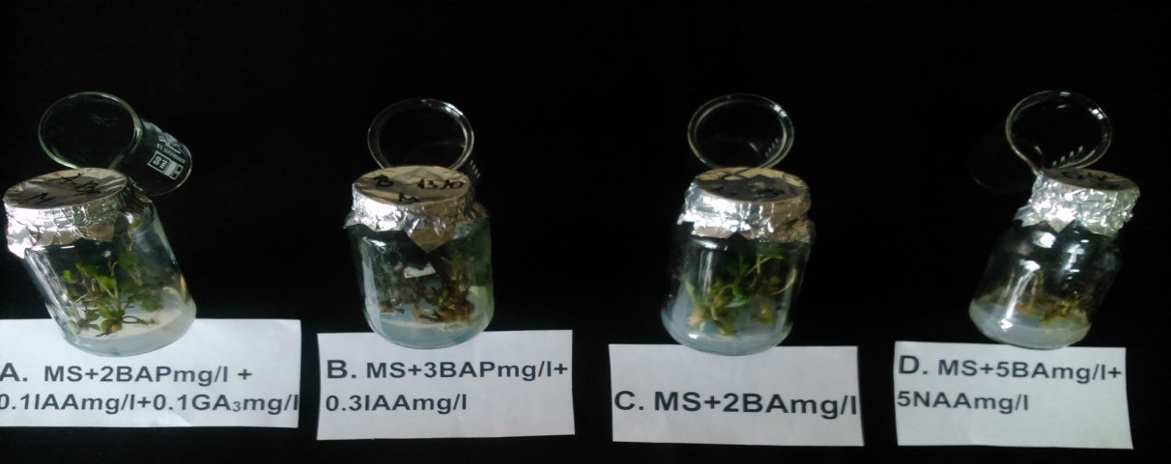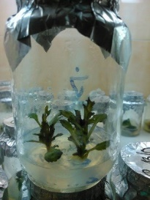
Figure 2. Shoot regenerants as result of the effect of MS medium and different growth regulators on meristem buds of ornamental red cabbage one month after the initial cultivation.
Reference to articles throughout the text as:
Table 2 shows the number of species;
The highest number of the species was in March (Fig. 3, Tab. 1).
When using units and symbols, the authors need to apply International System of Units, SI System.

CONCLUDING REMARKS
Subtitle
Text, text, text, text, text, text, text, text, text, text, text, text, text, text, text, text, text, text, text, text, text, text, text, text, text, text......
In the text, the references should be cited as the following examples: Novakov (2001) or (Dumas et al., 2006, 1999).

ACKNOWLEDGEMENT (optional)
Financial support, advice or other kinds of assistance can be included in this section

REFERENCES
Journals
Avinion, G., Greeg, D., & Johnsom, J. (2006). Characterization of some colliform bacteria isolated from pork meat. Journal of Veterinary Pathology, 88(3), 321-324.
Dimitrovski D. (2004): Organic seed production of vegetables. VIII Symposium Biotechnology and Agroindustry, Velika Plana, Serbia and Montenegro. Proceedings: 252-259.
Mitrev, S., & Kovacević, B. (2006). Characterization of Xanthomonas axonopodis pv. vesicatoria isolated from peppers in Macedonia. Journal of Plant Pathology, 88(3), 321-324.
Books
Pejcinovski, F., & Mitrev, S. (2007). Agricultural Phytopathology. Stip, Republic of Macedonia: “Goce Delcev” University.
Chapter of the book
Okuda, M., & Okuda, D. (1993). Star trek chronology: The history of the future. New York, NY: Pocket Books.
Presentations and scientific conferences
Dimitrovski, D. (2004). Organic seed production of vegetables. VIII Symposium Biotechnology and Agroindustry, Velika Plana, Serbia and Montenegro. Proceedings: 252-259.
Ivanov, B., & Todorovska, K. (2003). Analysis of air pollution in Veles region. Congress of Ecologist of the Republic of Macedonia, Ohrid. Proceedings: 246-252.
Magazines
Mershon, D. (1998, November/December). Star trek on the brain and alien minds, human minds. American Scientist, 86(6), 585.
Newspaper
Talevski, B. (2008, March 15). Total management in managing information network Infoservis. Business, pp. 8.
Encyclopedia
Sturgeon, T. (1995). Science fiction. In The Encyclopedia Americana (Vol. 24, pp. 390-392). Dabury, CT: Grolier.
Web-site
Statistical Office of the Republic of Macedonia (2009, March 4). Statistical yearbooks of the Republic of Macedonia. Retrieved from http://www.stat.gov.mk
Simmons, B. (2015, January 9). The tale of two Flaccos. Retrieved from http://grantland.com/the-triangle/the -tale-of-two-flaccos/

Filled in by Editorial office of JAPS - for authors who are not Macedonian speaking
НАСЛОВ НА ТРУДОТ (МИКРОПРОПАГАЦИЈА НА ОРНАМЕНТНИТЕ ВИДОВИ Brassica oleracea cv. Kyoto Red Given И Ageratum sp.)

Име и презиме^{1*}, Име и презиме ² на авторот/ите
¹Адреса на авторот/ите, (адресата на автори од различни институции да се обележи со суперскрипт)
²Адреса на авторот/ите, (адресата на автори од различни институции да се обележи со суперскрипт)
*Контакт автор: е-пошта

Резиме
Резиме на македонски јазик, максимум до 250 зборови.

Клучни зборови: 3-7 зборови кои не се вклучени во насловот

Journal of Agriculture and Plant Sciences, JAPS, Vol. --, pp. -- - --

